PRESS RELEASE

Longiano (FC) Italia, 25th August 2018

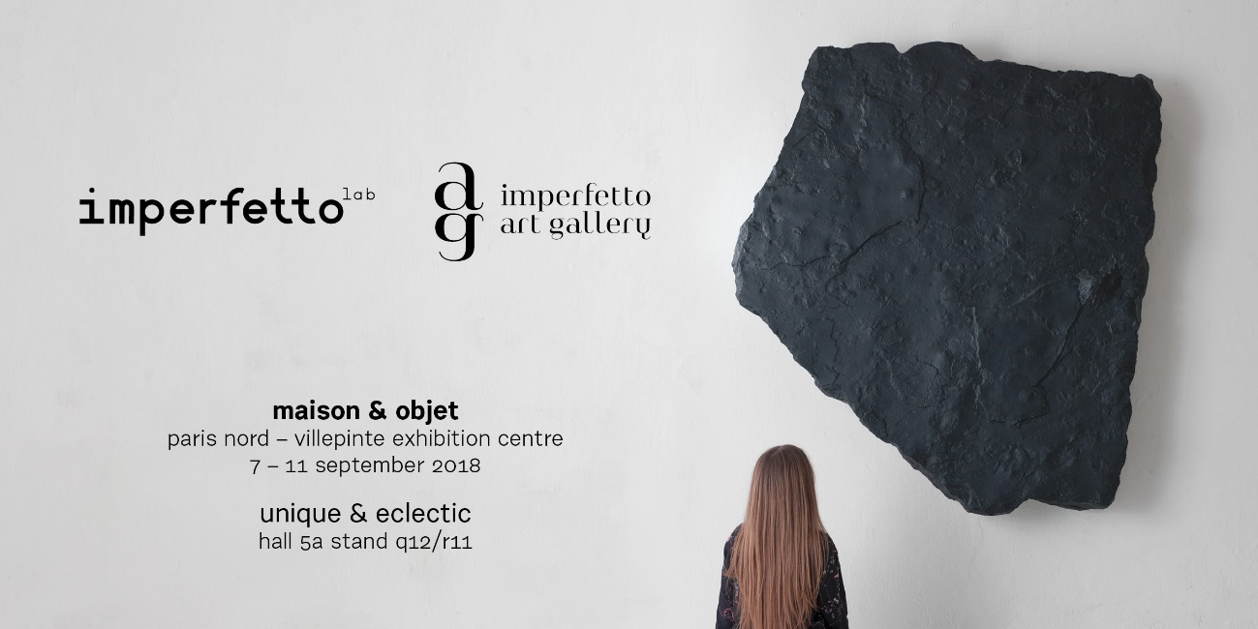

Maison&Objet chooses Imperfettolab for the new Unique&Eclectic section
unique and refined pieces, between art, design and craftsmanship.
The partnership between Imperfettolab and BOON_Room begins at
Paris Design Week

Paris 7-11/09 Maison&Objet 6-15/09 Paris Design Week

Bye–bye routine, hello surprise! We evolve for you, is the slogan chosen by Maison&Objet to announce the latest that can be admired at Parc des Expositions of Paris Nord - Villepinte, starting from next September 7th.

With the Unique&Electic section, dedicated to innovative design from all over the world, Maison&Objet evolves towards ever more surprising forms of living and dwelling. And it is here that Imperfettolab will present its next theatrical booth set-up, made of design and works of art.

Also in the context of Maison&Objet, in the space What's new? “Decor” (Hall 3), François Delclaux, style and trend consultant, will present his selection of furnishing elements, divided by theme, which stand out for their ability to confer a particular atmosphere to an environment and a precise state of mind. Unique pieces for innovation of the concept and the materials used. Unda and Fondamenta, signed by Verter Turroni for Imperfettolab, will be among the objects to be discovered. An award that also extends into the exclusive Le Club space (Hall 5A Mezzanine), designed by Cédric Martineaud, the art director of 14Septembre, who has chosen Midi and Olivia armchairs by Imperfettolab to welcome the most influential actors in the art de vivre industry.

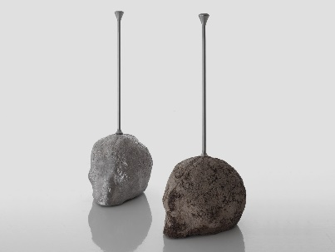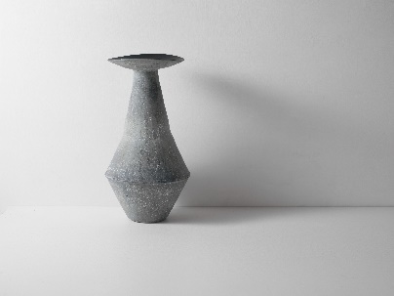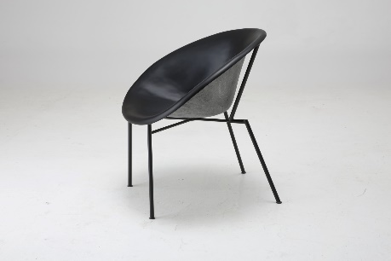

Paris Design Week, in synergy with the September session of Maison&Objet show, from 6th to 15th September immerses the French capital in a party outside the Expo that invades the city, for anyone who is interested and curious, for professionals and young talents. Galleries, museums, institutions and public places celebrate the great design event with exhibitions, installations, talks and cultural events in an effervescent atmosphere, full of new ideas and trends.

Imperfettolab will be present in the lively neighbourhood Bastille at BOON Paris which for this occasion will inaugurate BOON_Room boutique gallery & concept store. A 250 m2 gallery-boutique and 400 m2 showroom dedicated to the promotion of unique talents in the fields of Art, Design and Fashion. Here Imperfettolab will present some of the most representative pieces of its collection along with works of art by Erich Turroni and Verter Turroni. So the collaboration between BOON, Imperfettolab and Imperfect Art Gallery will begin.

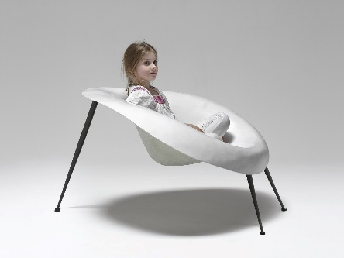
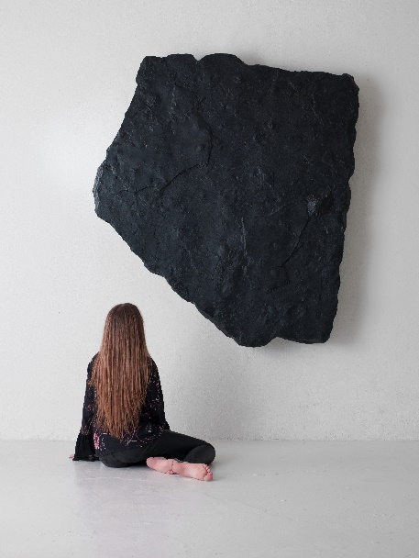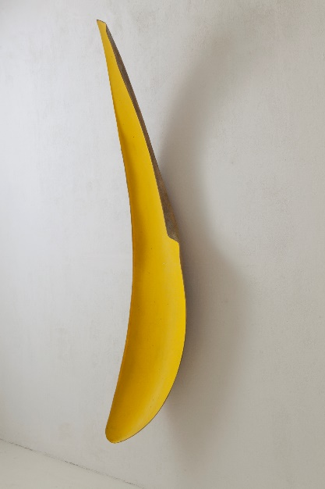

Since the beginning, next to the laboratory of Imperfettolab, stands a contemporary art exhibition space, but also a place to live, sit and have a conversation with friends and artists of various origins, in an environment where furnishing objects interact with works of art. A space that today, with the name of Imperfetto Art Gallery, is being redesigned and expanded in a factory in Longiano, in Emilia-Romagna, the opening is scheduled for next autumn.

Inside a world that flees and asks to be consumed, when design seems to follow the dynamics of fashion and to suggest an incessant race to production, it is a lucid thought that drives the choices of the Imperfettolab family: to take the time and space to support and plan artistic initiatives together with the work of the laboratory, in a single cultural vision.

Imperfettolab takes a way of understanding design beyond national borders. The continuous research for materials, shapes and techniques, creates collections that are appreciated by architects and waited for by collectors. In an increasingly demanding and constantly changing market such as design, the eclecticism of the artists and designers of Imperfettolab has not gone unnoticed, receptive and attentive to the world around them but faithful to the hazard of their own sensitivity. They leave a mark of contemporary taste that time turns into classical.
This is how made in Italy signed by Imperfettolab was born.

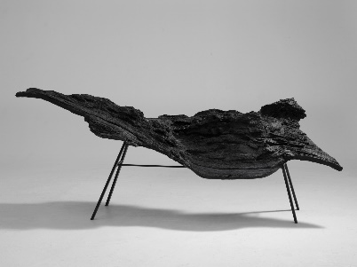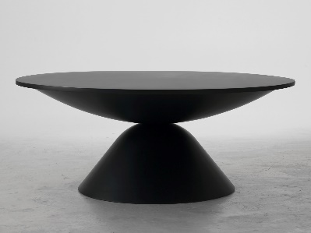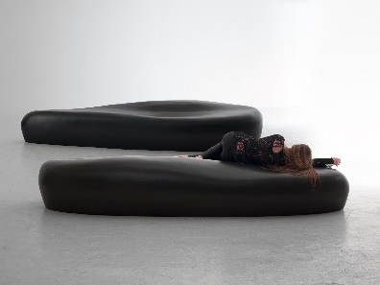

Maison&Objet – Signature: Unique&Eclectic
Hall 5A - Stand Q12 / R11

Imperfettolab -
Communication & press
Angela Gorini
mob. +39 328 7817779
press@imperfettolab.com

imperfettolab.com
instagram.com/imperfettolab/

